SCALE Task:
- Teacher to gather students into 4 – 6 groups of 4 people depending on class size. (2 people needed to stretch out tape measure. 2 People to mark out measurements with tape.

- Give students the following items:
- Task sheet: 1-6 (one each group)
- Tape measure
- Masking Tape
- Scissors

- Students and teacher to gather in JPC Atrium with all items above.

- Set time for Task i.e. 20 minutes. (Could have prizes for 1st place…)

- Students to measure out on floor the Scale/size of each painting and use masking tape to show the frame/size.

- When complete place the Task card face up on the ground within the masked space. Students to walk around and imagine the work this scale…

- Discuss:
- How important was Scale?
- Why were these paintings so large?
- What was the artist trying to express?
- How does Scale affect the viewer?
- How did this exercise make you feel?
- Do you think Scale relates to the context i.e. ‘the Industrial Revolution’? How?

- Clean up Tape and put in bin
Well done!
SCALE 1:
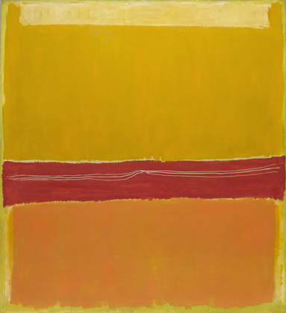

Artist: Mark Rothko
Title: No.5/ No. 22
Date: 1950 (dated on reverse 1949)
Medium: Oil on canvas
Measurements: 297 x 272cm
SCALE 2:

Artist: Barnett Newman
Title: Vir Heroicus Sublimis
Date: 1950 - 51
Medium: Oil on canvas
Measurements: 242.2 x 541.7cm

SCALE 3:
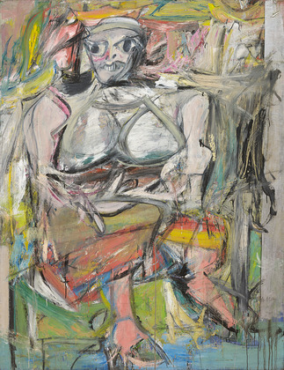

Artist: Willem De Kooning
Title: Woman 1
Date: 1950 - 52
Medium: Oil on Canvas
Measurements: 192.7 x 147.3 cm
SCALE 4:
Artist: Jackson Pollock
Title: One: Number 31
Date: 1950
Medium: Oil & Enamel on canvas
Measurements: 269.5 x 530.8cm

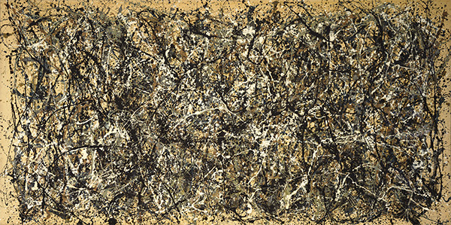

SCALE 5:
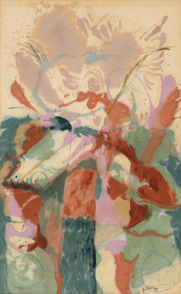

Artist: Helen Frankenthaler
Title: Jacobs Ladder
Date: 1957
Medium: Oil on canvas
Measurements: 287.9 x 177.5cm

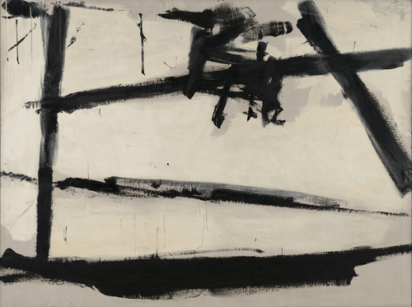
SCALE 6:

Artist: Franz Kline
Title: Painting Number 2
Date: 1954
Medium: Oil on Canvas
Measurements: 204.3 x 271.8cm

