**TASK:**

Using the books available in the classroom and on-line resources (especially [www.wga.com](http://www.wga.com)), **research at least one of these artworks**.

**Head up the title and date of the artwork and the artist and then write an account of the work. In your account you should include comments on the following:**

**THE ARTIST –** Who was the artist? Where did he work? What were his theoretical, professional and/or personal influences?

**CONTEXT –** What was the original purpose of the artwork? Why and for who was it made? List at least two contextual historical factors. Can you see any evidence of contextual factors (biographical and/or historical) in the work? What are they?

**STYLE –** Describe the work in detail. Make comments on specific stylistic features such as composition, colour, line, form, light, brushwork, and tone.

**MEANING** – What is the subject matter of the art work? Who are these people, objects, symbols, and creatures? What are they doing? What do they mean? What is the ‘content’ of the art work: an important idea conveyed? What is the work ‘saying’, about the subject, the artist, the time it was made etc.? Might the meaning have changed over time? If so, how?

**COMPARISON** – Think of another art work you can compare this to (in terms of context, meaning and/or style). Write a brief comparison: how are they different? How are they similar?

**EVALUATION –** Why did you choose this work? Do you like it? Why/why not? What can you say about it in terms of the Renaissance and Mannerism in general? How does it relate to what you know about this period?

Angolo Bronzio, *Eleonora of Toledo with her son Giovanni de' Medici*  
1544-45, Oil on wood, 115 x 96 cm  
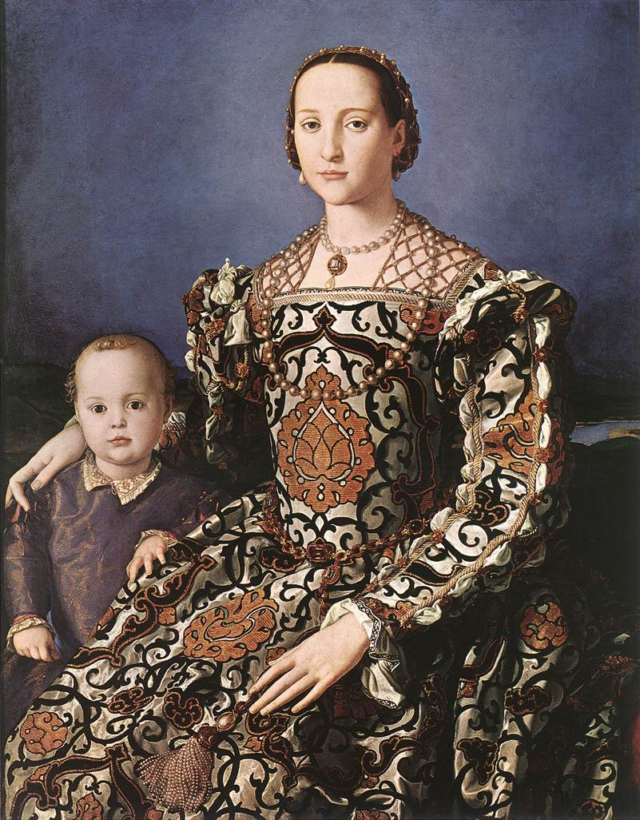

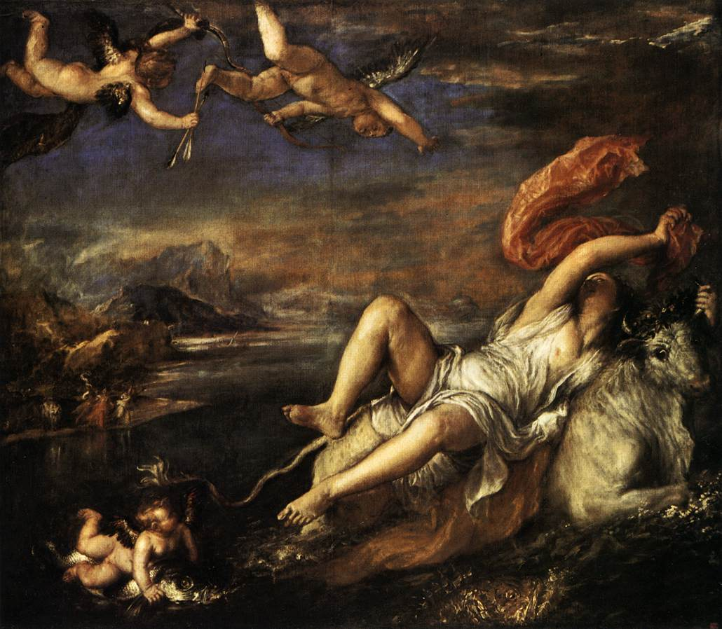

Titian, *Rape of Europa*, 1559-62  
Oil on canvas, 185 x 205 cm

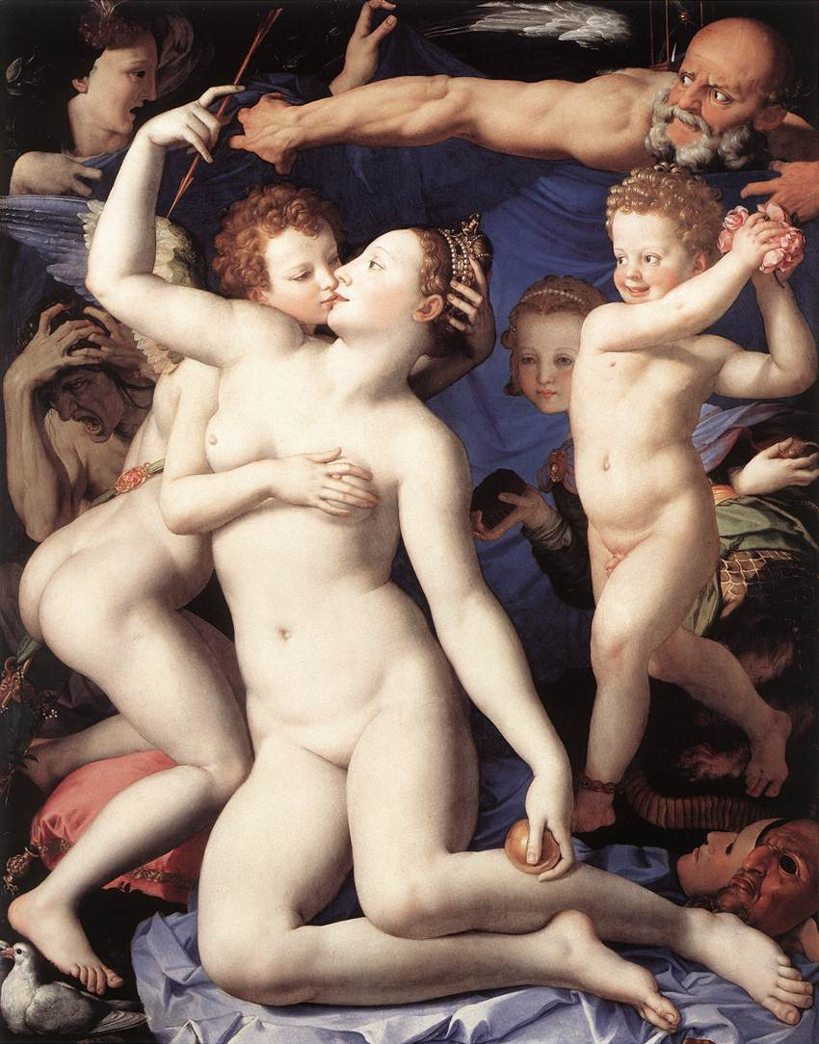

Angolo Bronzio, *Venus, Cupid and Time (Allegory of Lust),* 1540-45  
Oil on wood, 147 x 117 cm