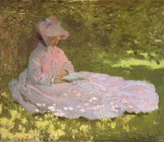
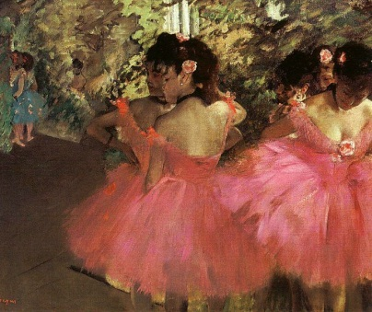
IMPRESSIONIST PAINTING TECHNIQUES
- For this activity select ONE art work each by
      - Monet
      - Degas
      - Renoir
      - Pissarro

- Give the title and date of each art work. Find the painting on a search engine and then enlarge so that you can see the brushstrokes of the painting. The form will probably be quite abstract so that the painting just looks like strokes or dabs of paint. You might want to also print off an copy of the entire painting as well to compare and indicate where your detail is found.
- Copy this section onto a piece of art paper using pencil, drawing in all the brushstrokes and labelling the various colours that are found. Size approximately 10 – 15cm square.
- Glue each square in your book and label with the artist, title, date and medium.
- Around each square, add annotated notes about the
  - form
  - use of colour/colour scheme
  - treatment of space/depth
  - technique
  - use of materials – ie. oils

- When you have completed all four of your studies, write a paragraph comparing the techniques of the four artists and the different effects that are created within each painting.
